**TASK-1:**

So in my first task I just have to copy the script and save it in the Samy’s about me section. Thus whenever the about me page is loaded it will prompt the alert tab.

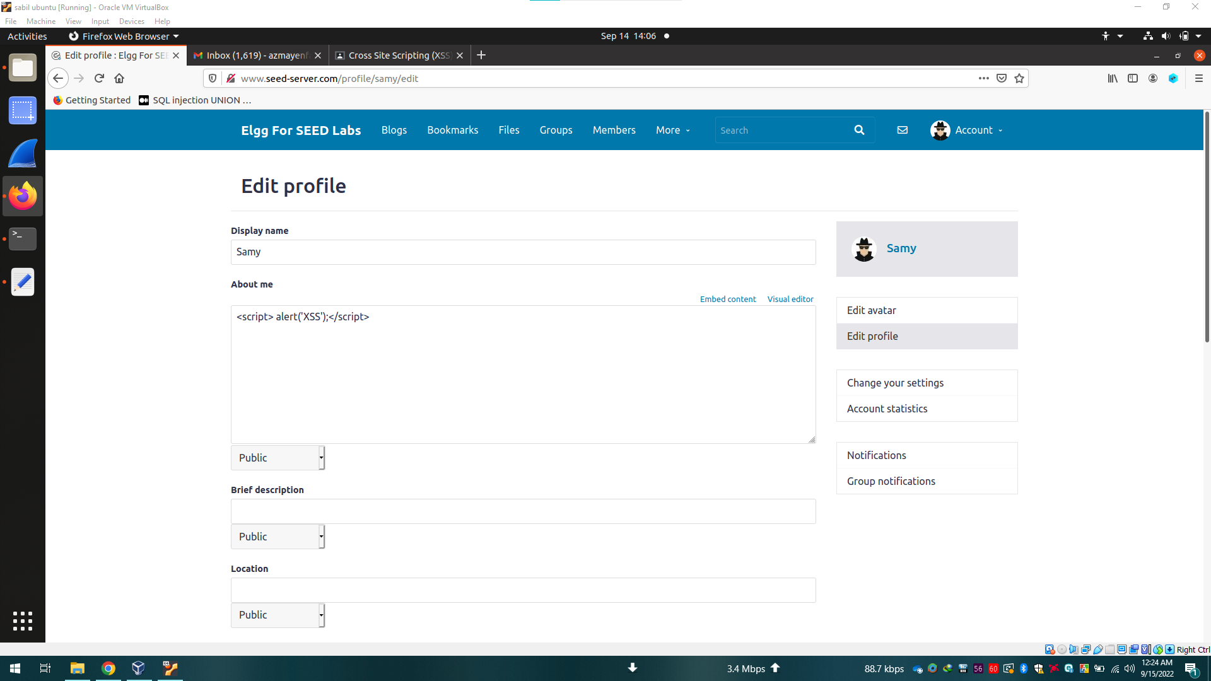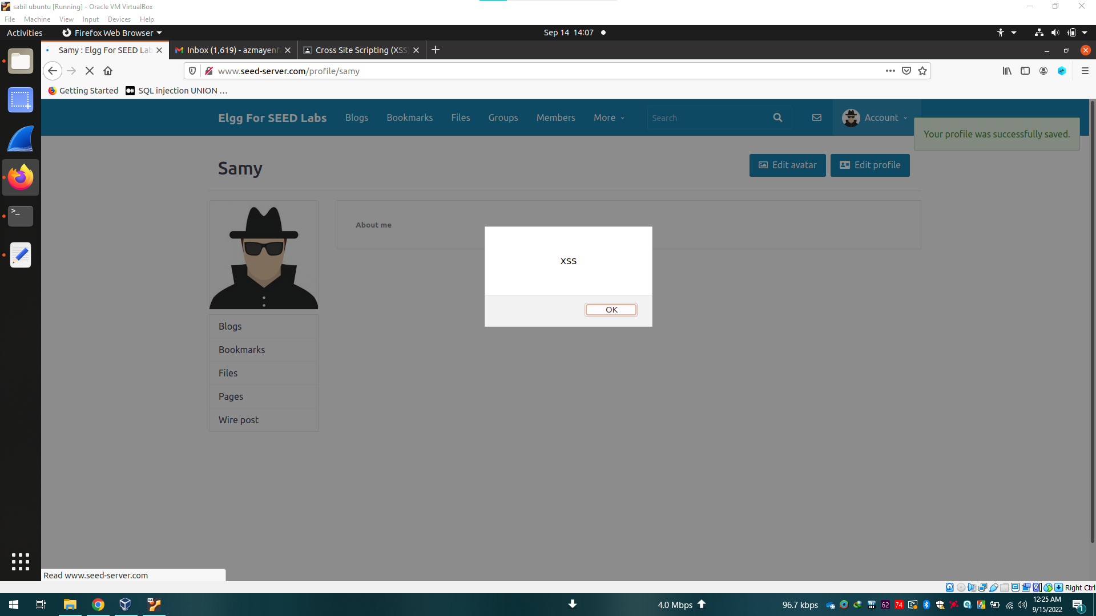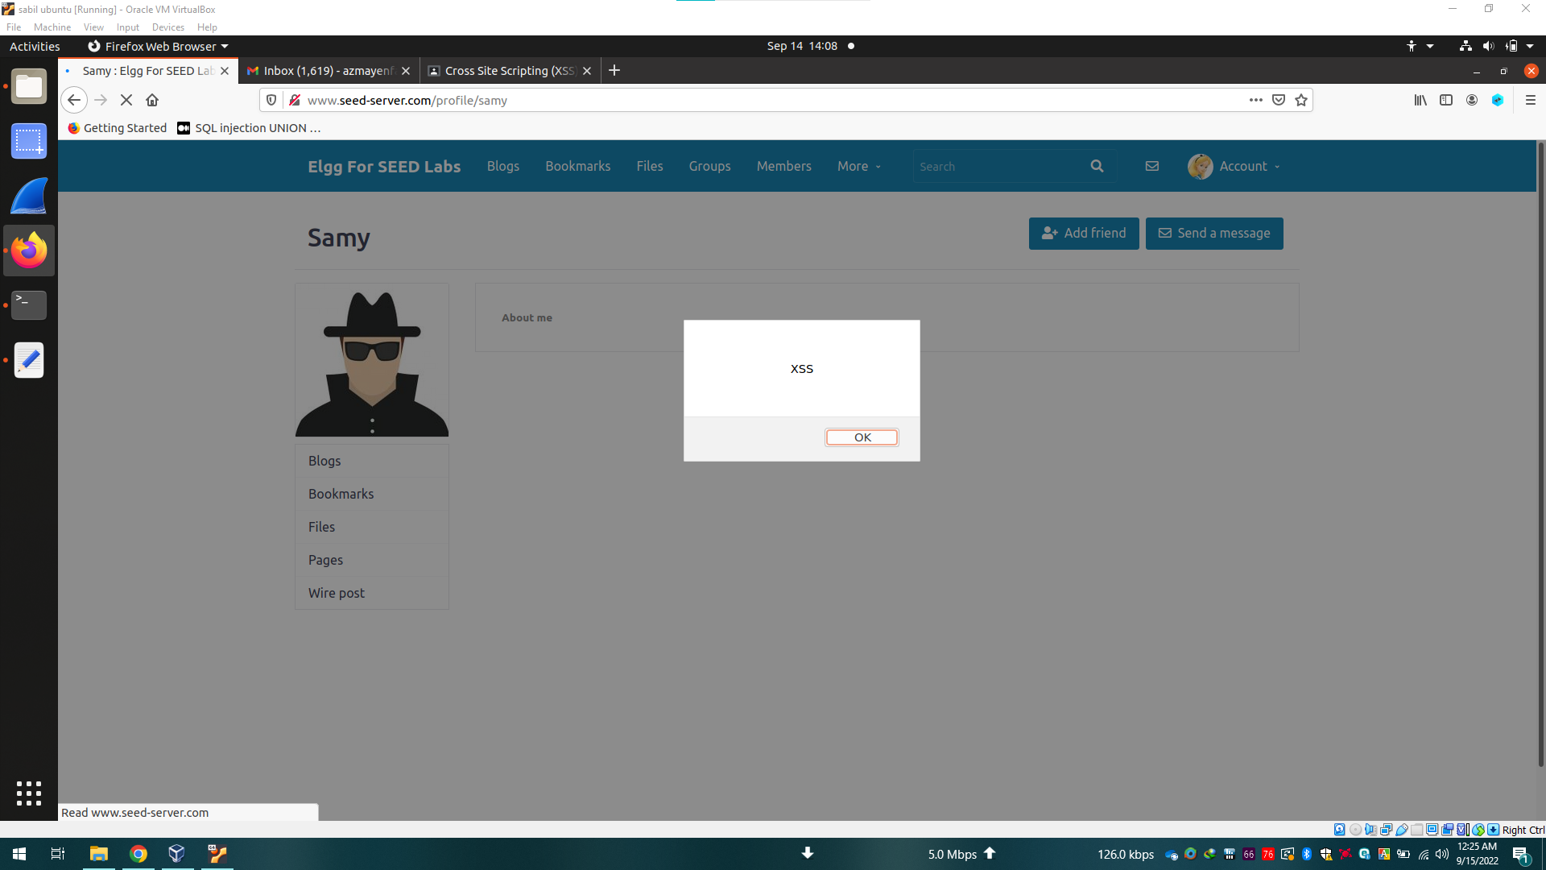

**TASK-2:**

In this task we can just use the script tag that we used in task 1 and modify the alert function by writing “document.cookie” inside.

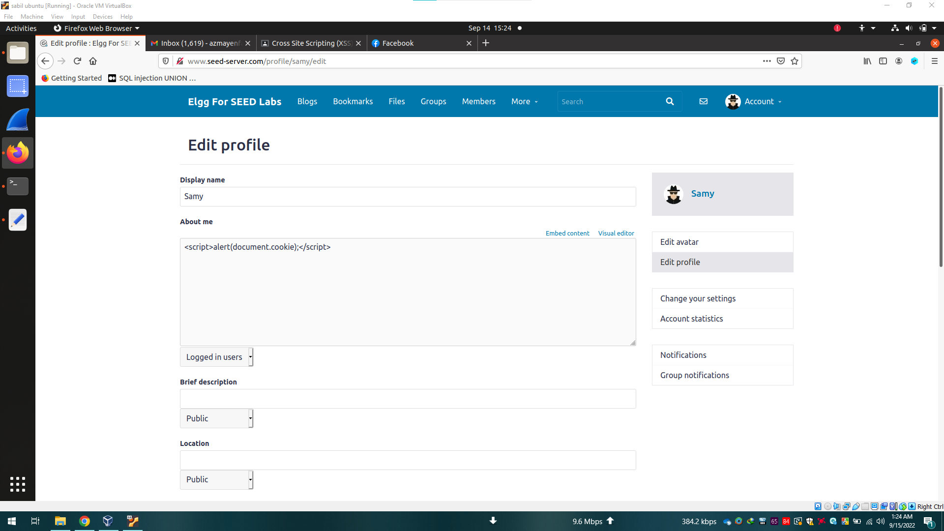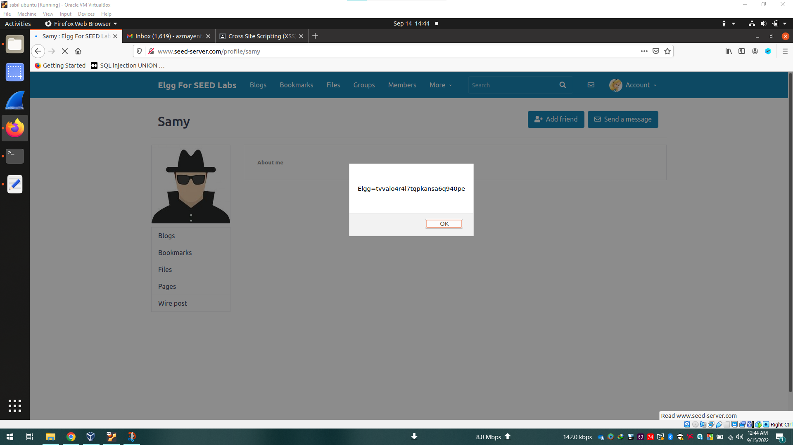

**TASK-3:**

In this task we have to consider few things:

* HTTP request URL after clicking add friend,
* Understanding the URL that we fetched using HTTP header live extension,
* Then we have to recreate the link inside a script tag and save it to the browser so that whenever a user visits the attacker's profile the script will automatically run and add the attacker as friend.

We are using Ajax so that the website doesn’t reload while passing requests and shows suspicious behavior.

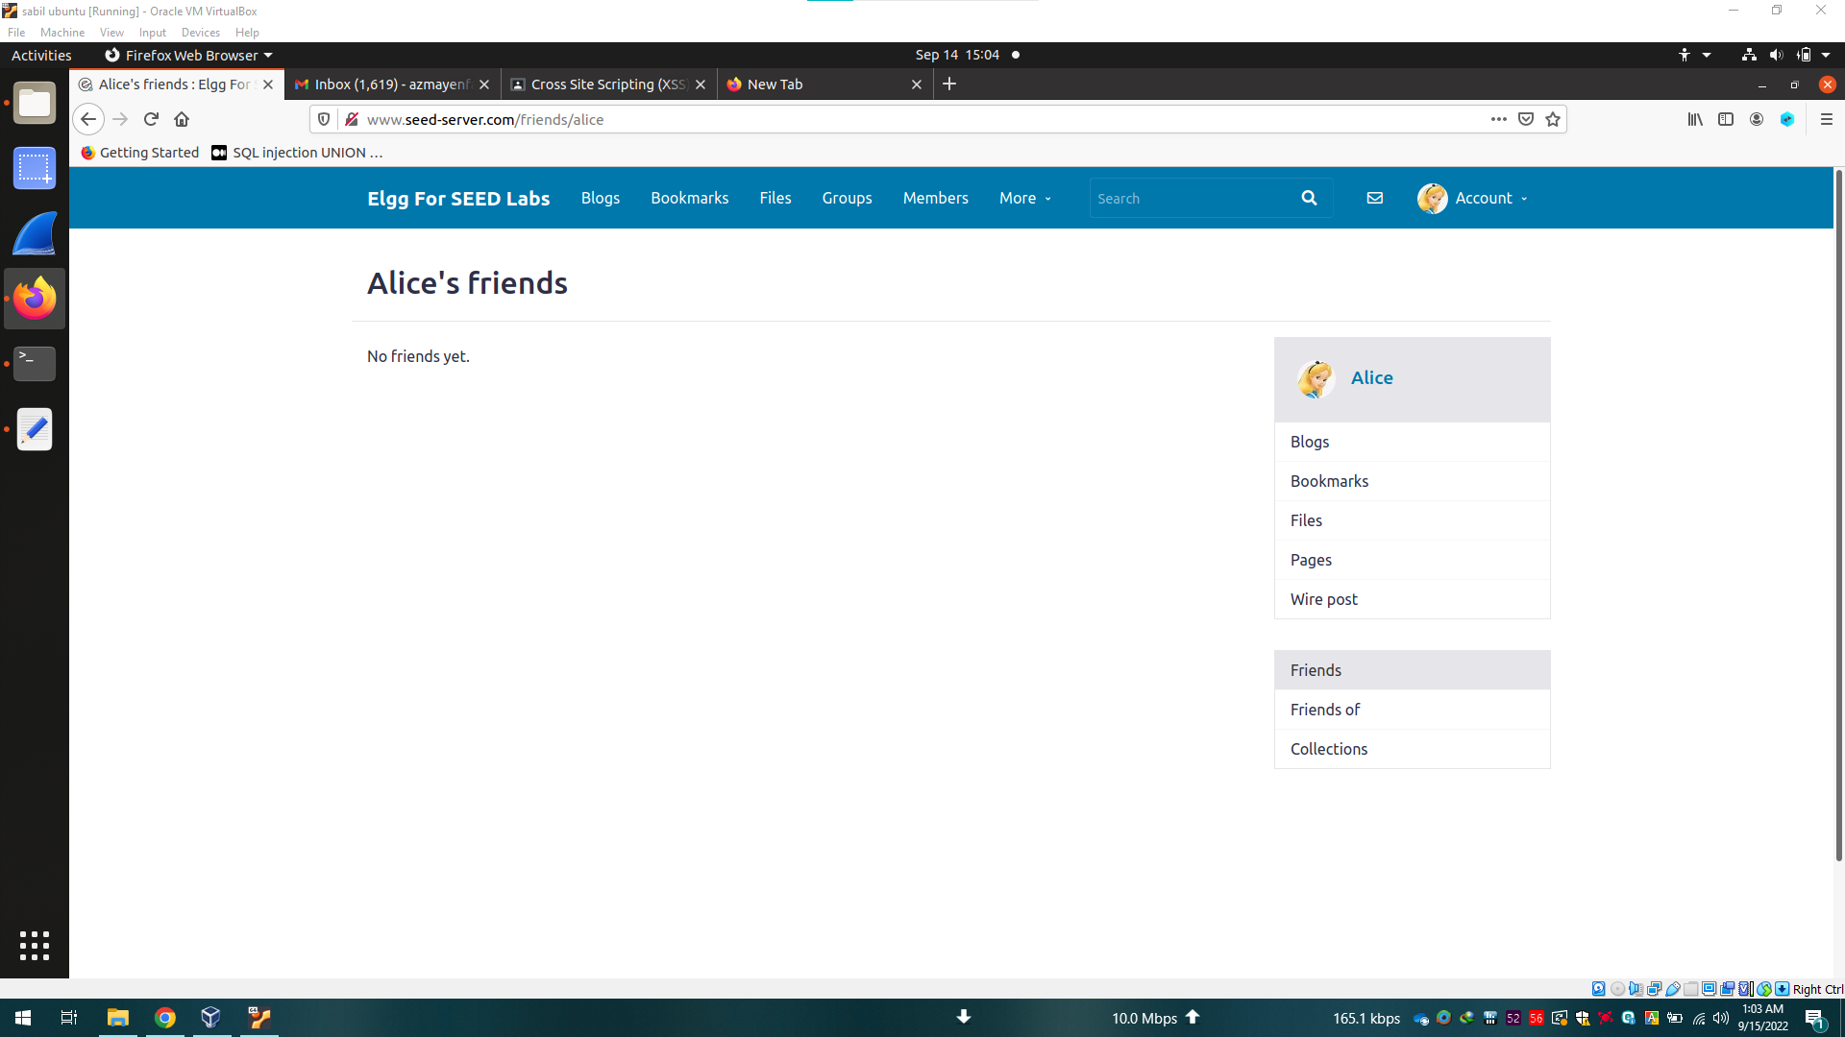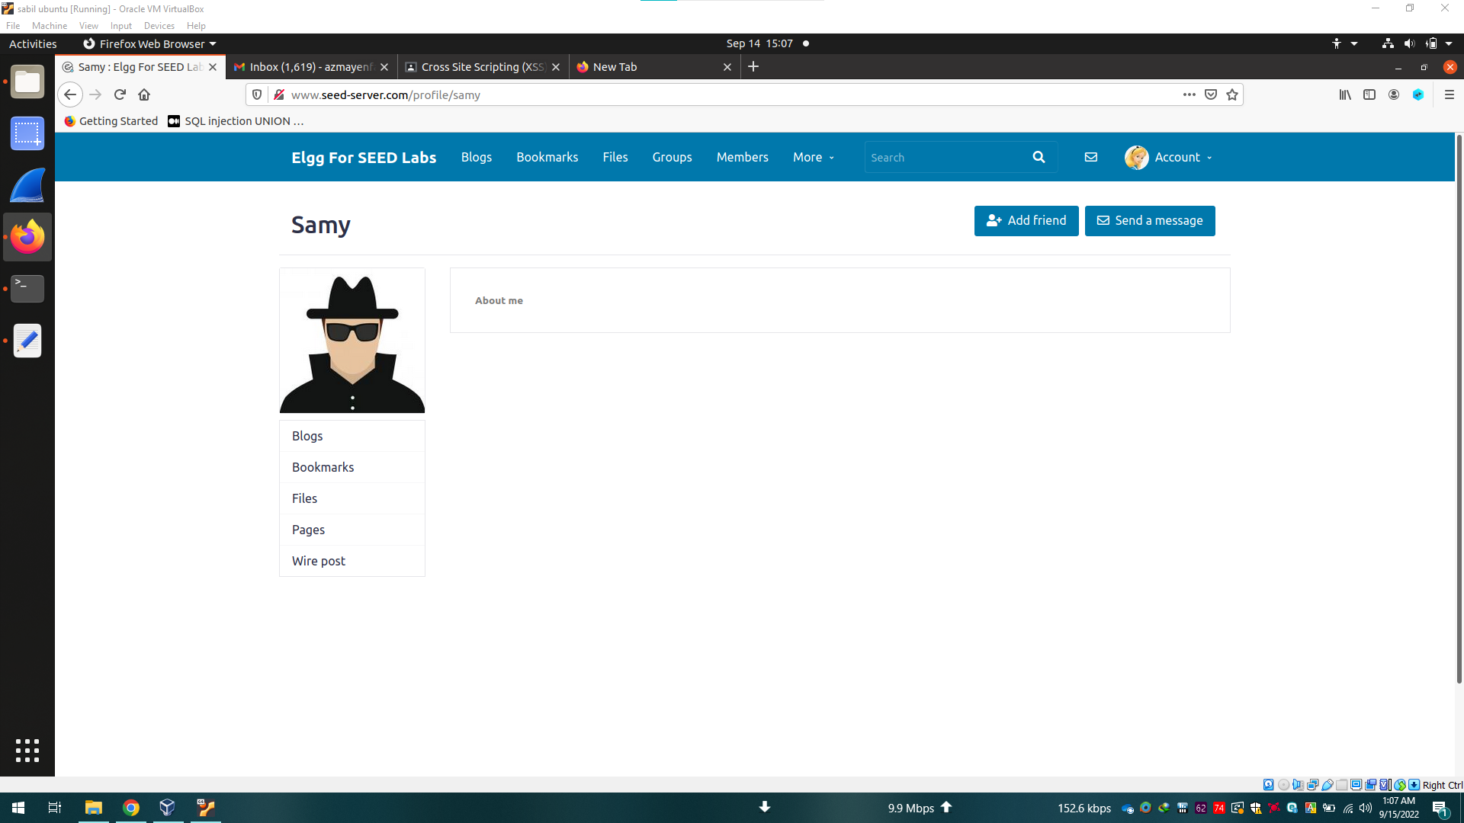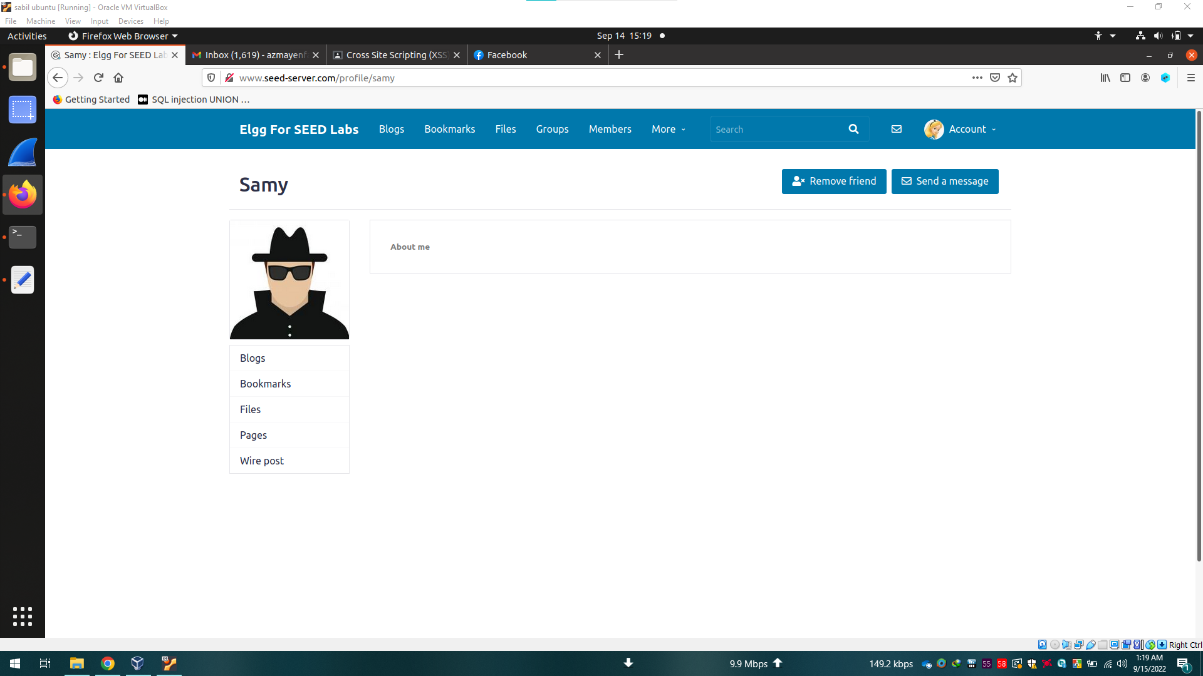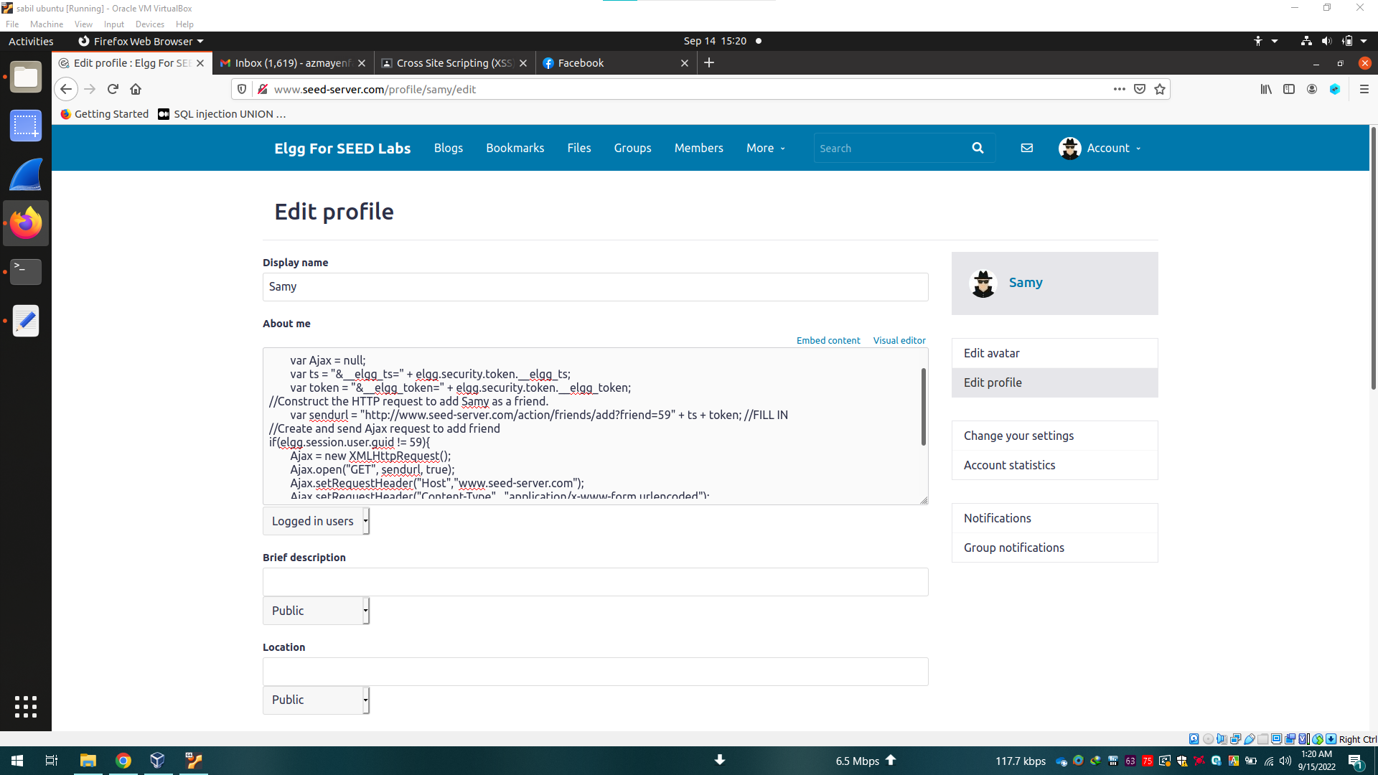

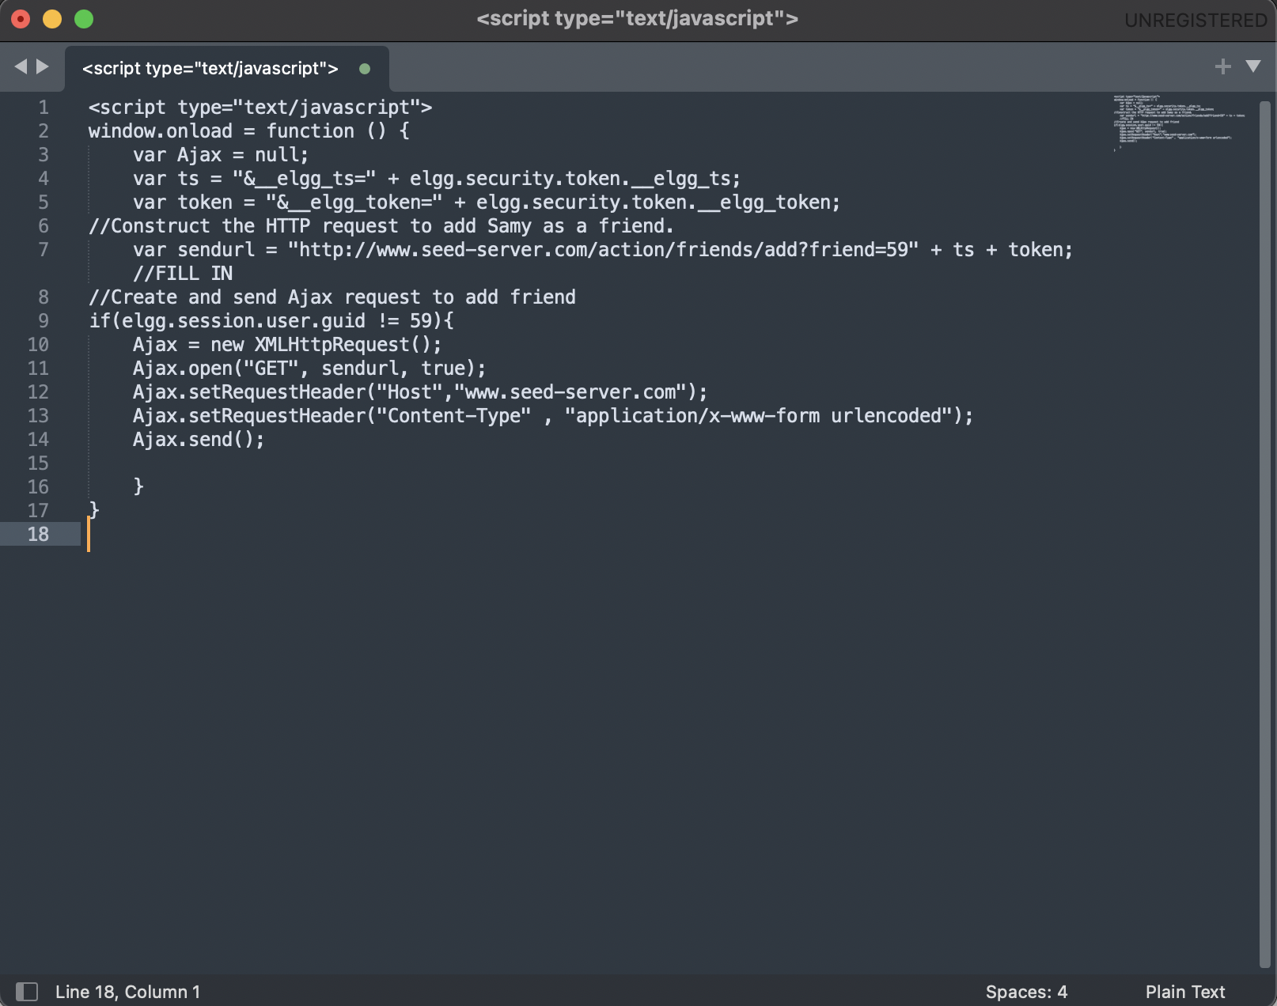

**TASK-4:**

This task is similar to the previous task. Here we also need to observe HTTP post URLs using the extension. Then we have to recreate that inside a script tag. And keep that code inside the attacker's profile. So whenever, any victim will visit the attacker's profile there will be a post request to change the victims brief description section and it will be changed.

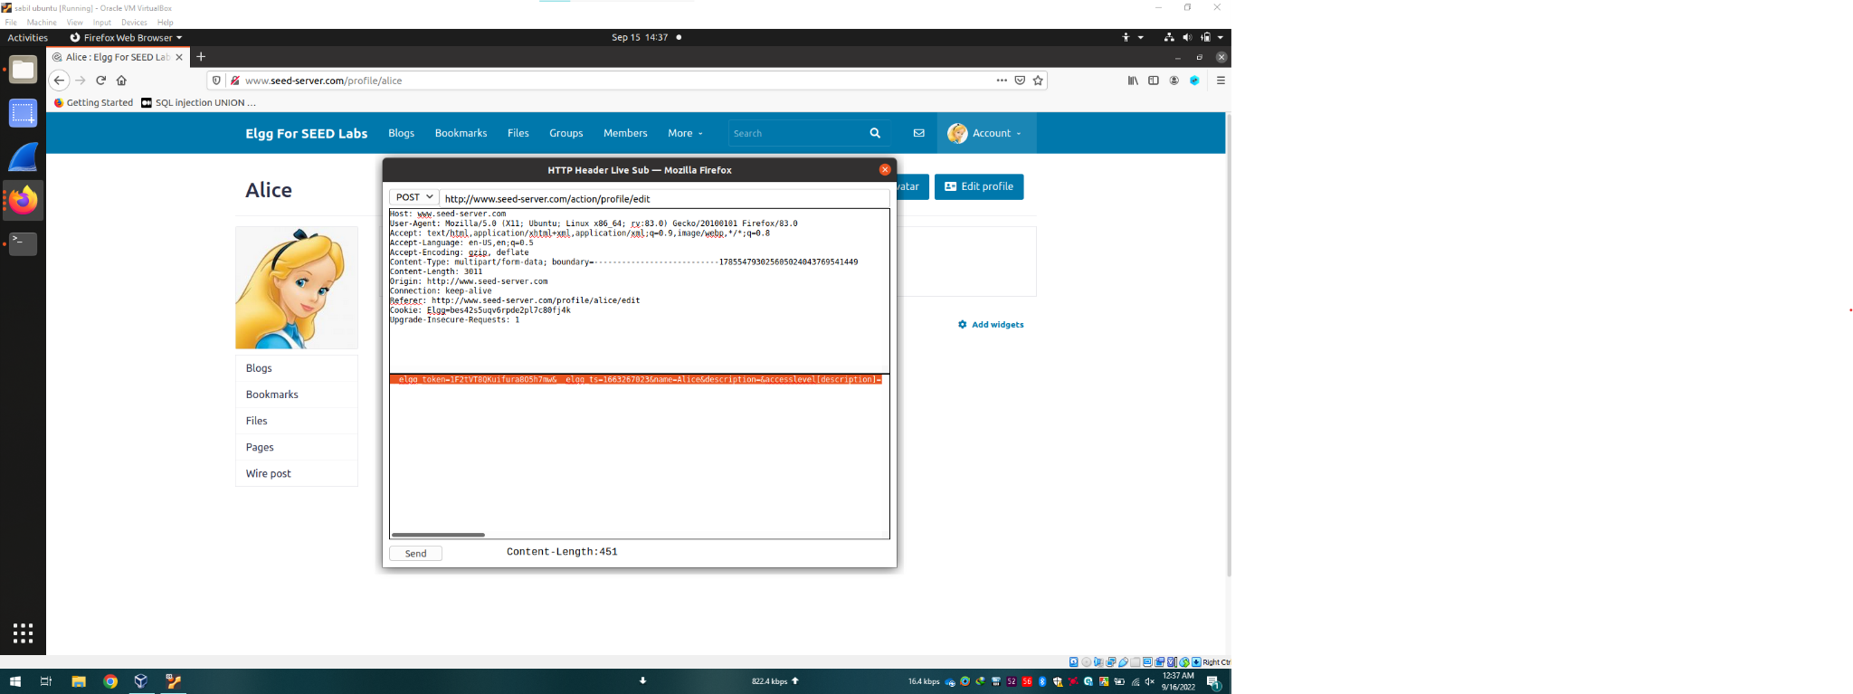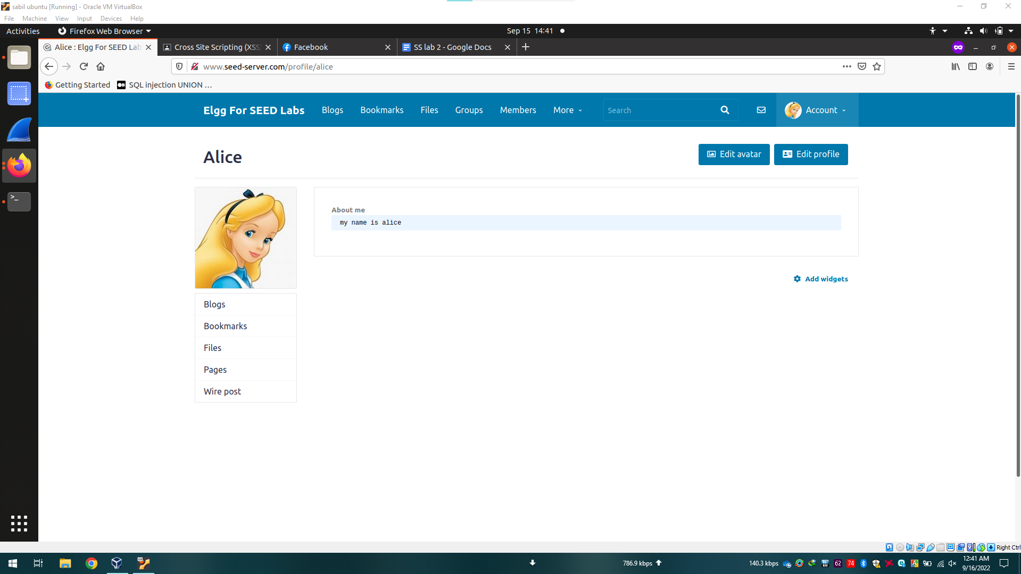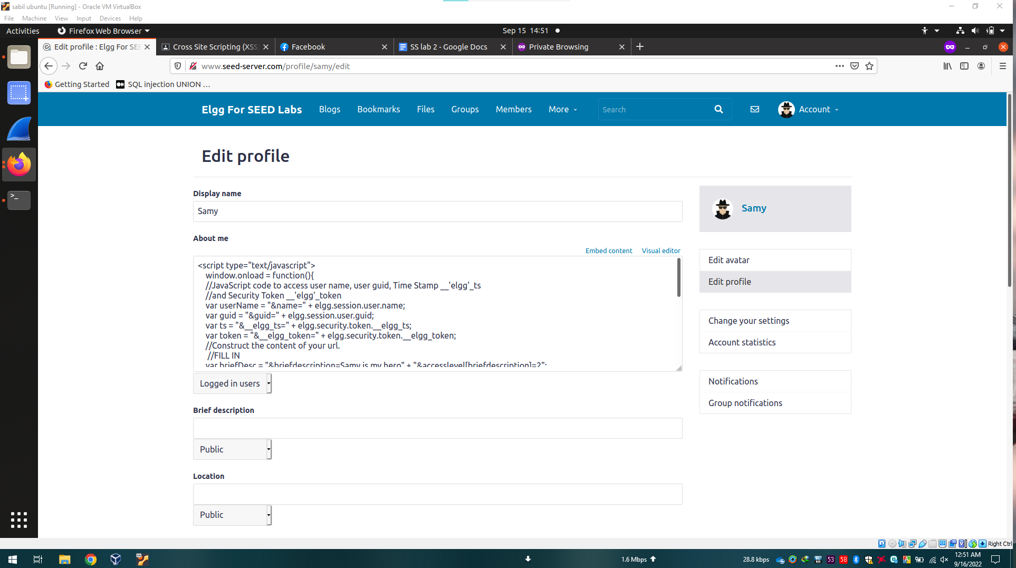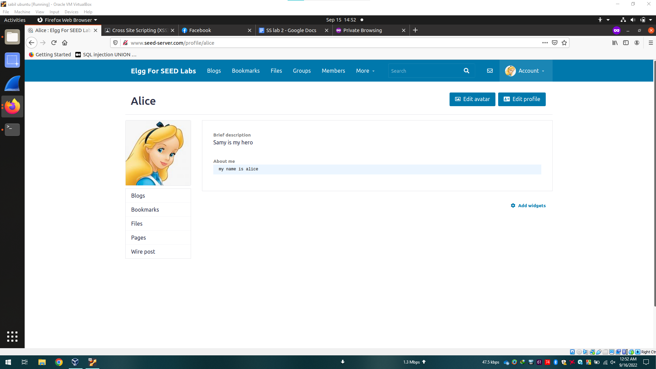

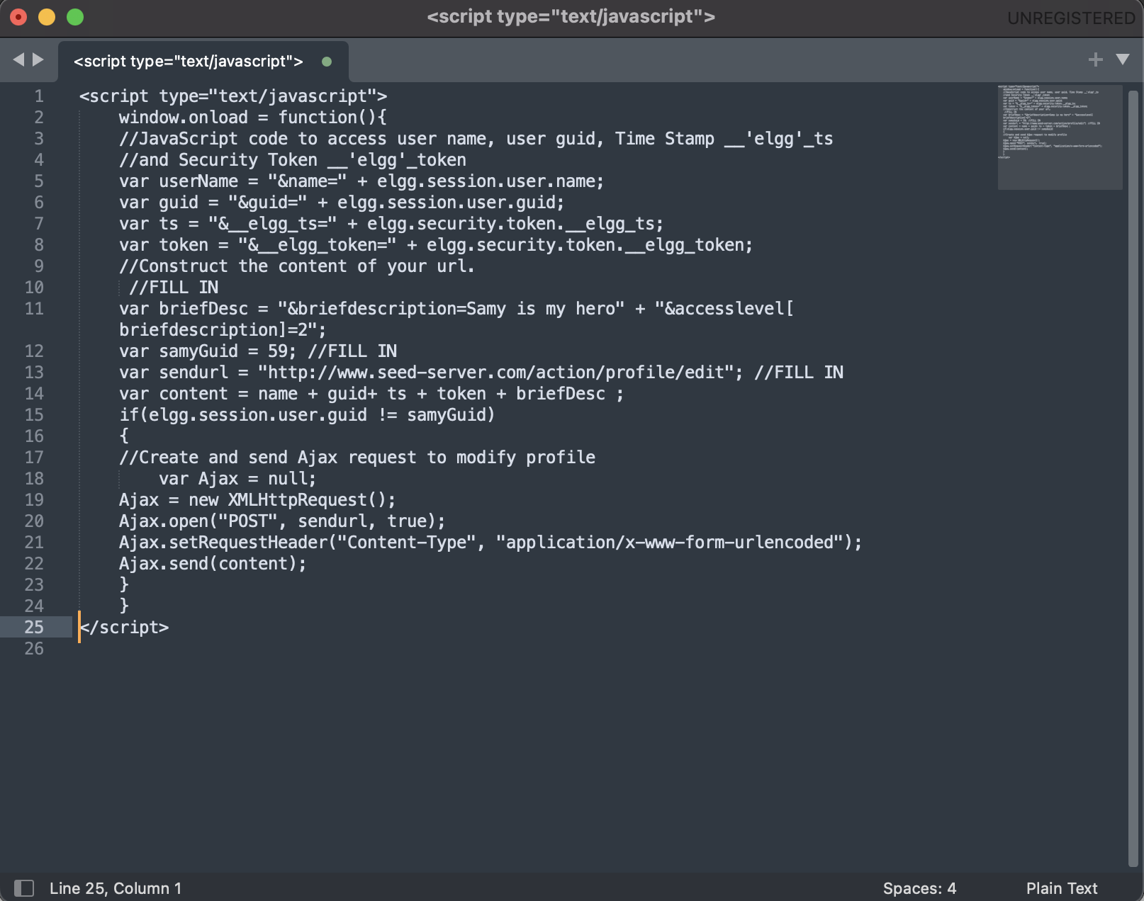

**TASK-5:**

This task is a merged version of the previous two tasks. We just have to create two requests in order to change the bio and add the attacker as a friend.

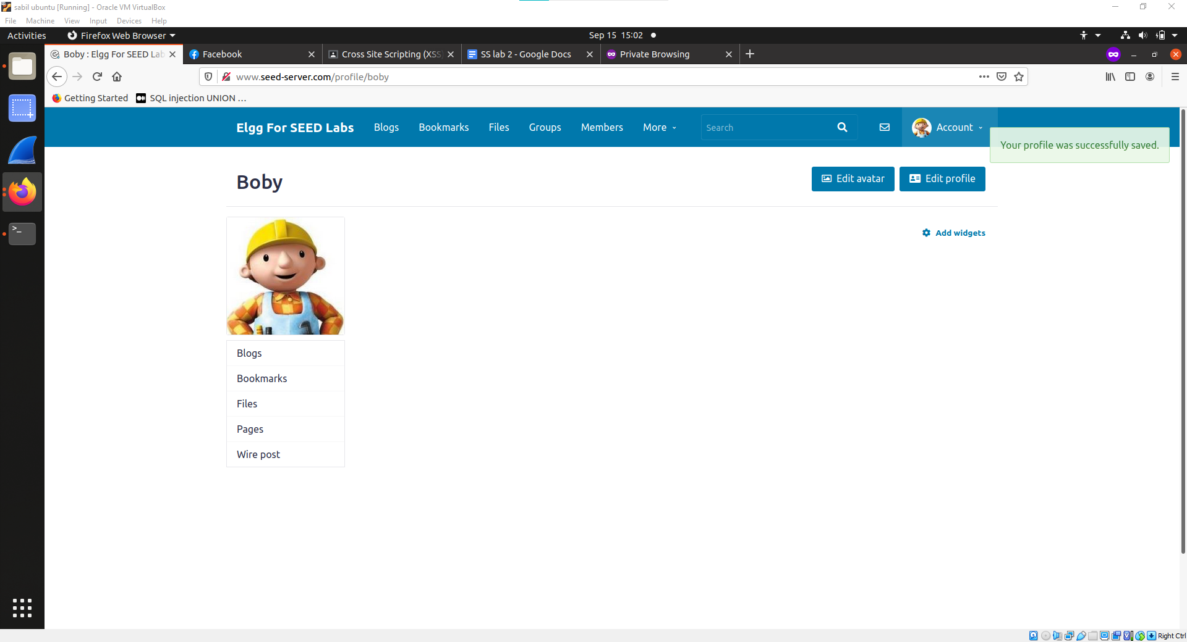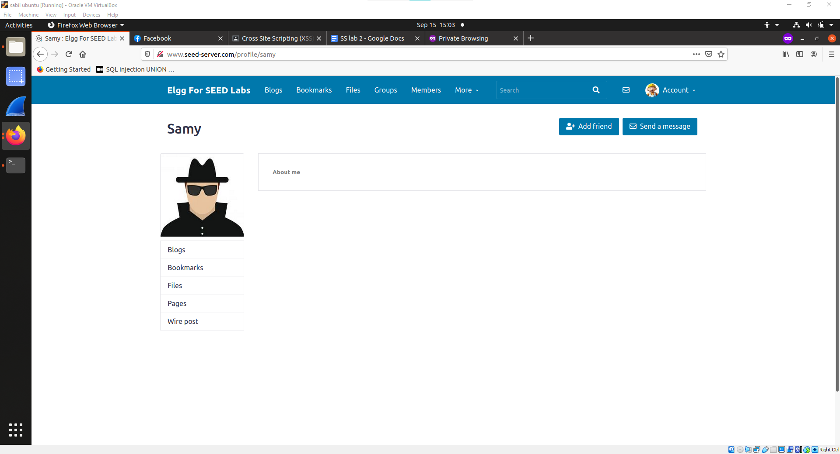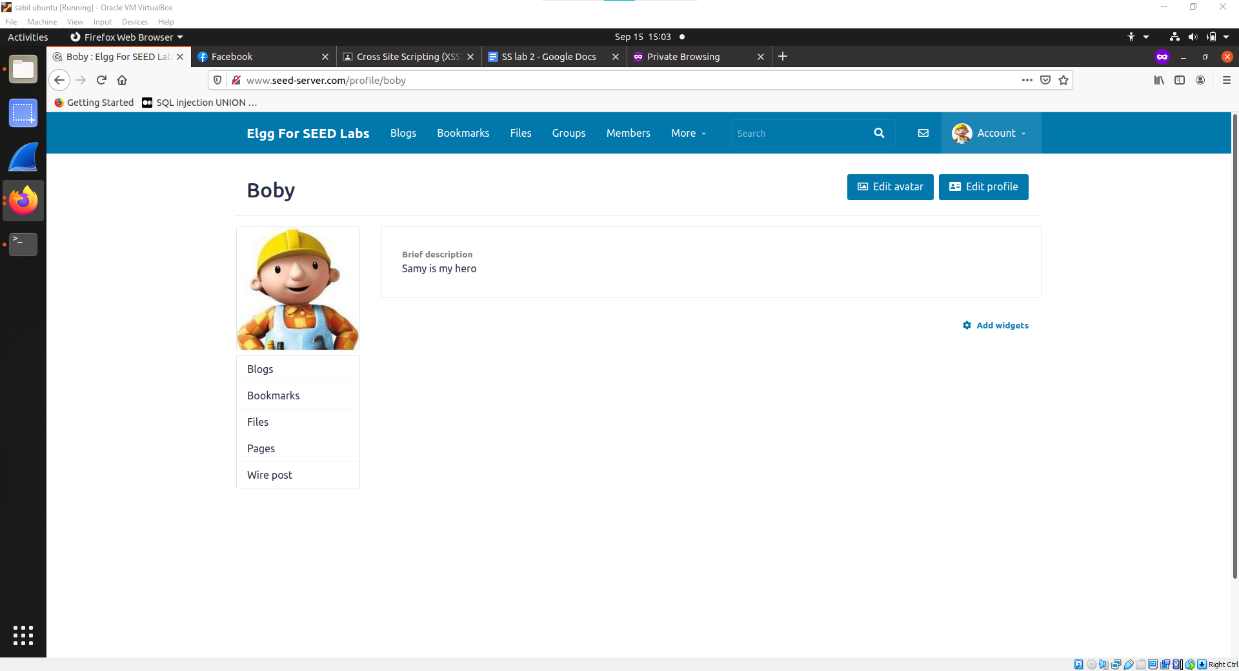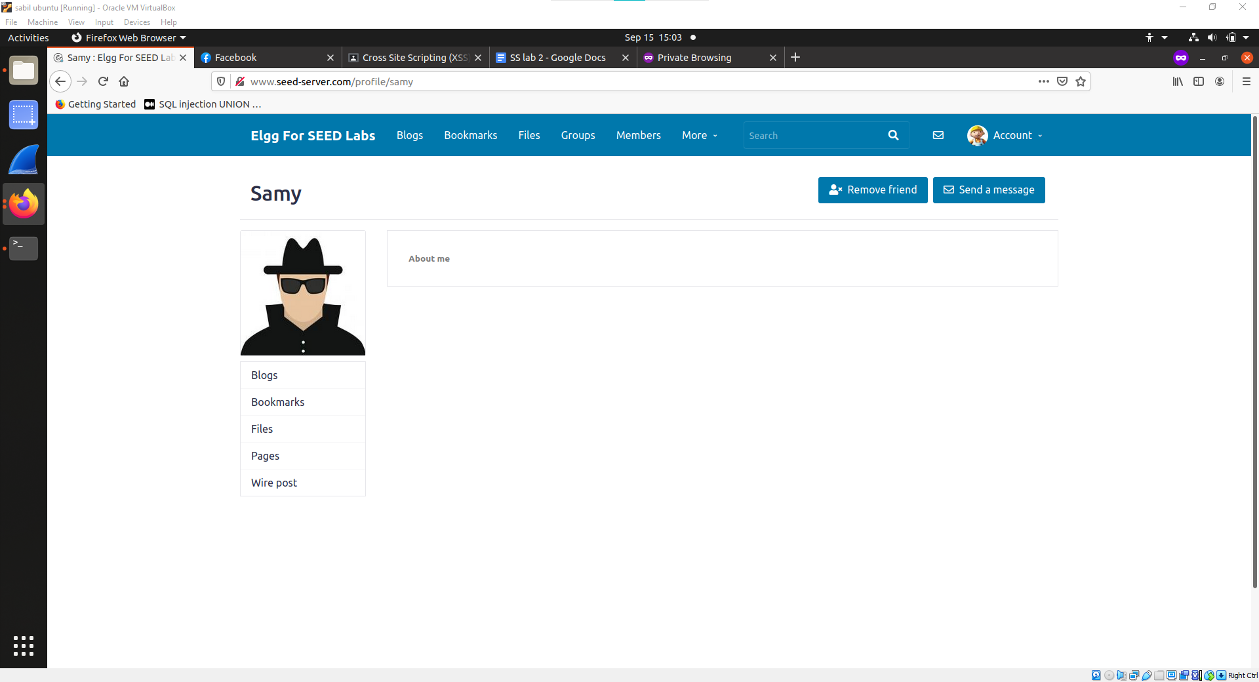

**TASK-7:**

This is similar to the task where we changed victims’ bio.

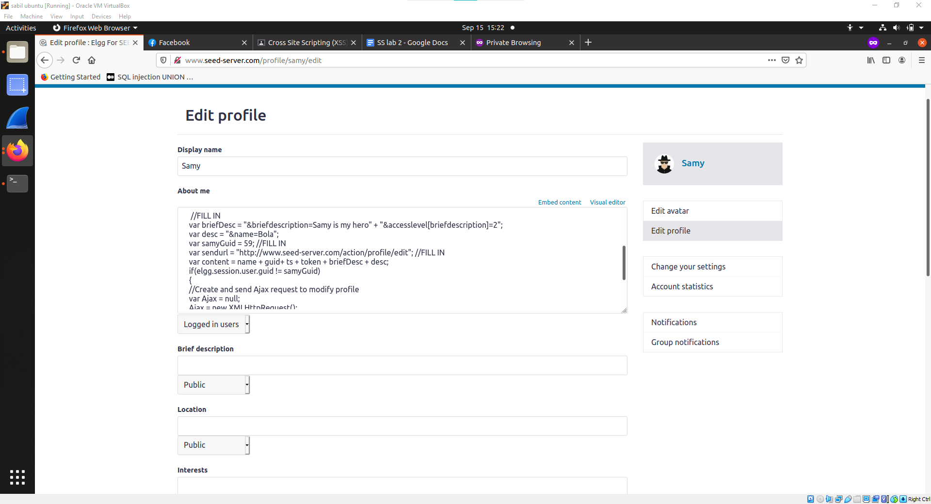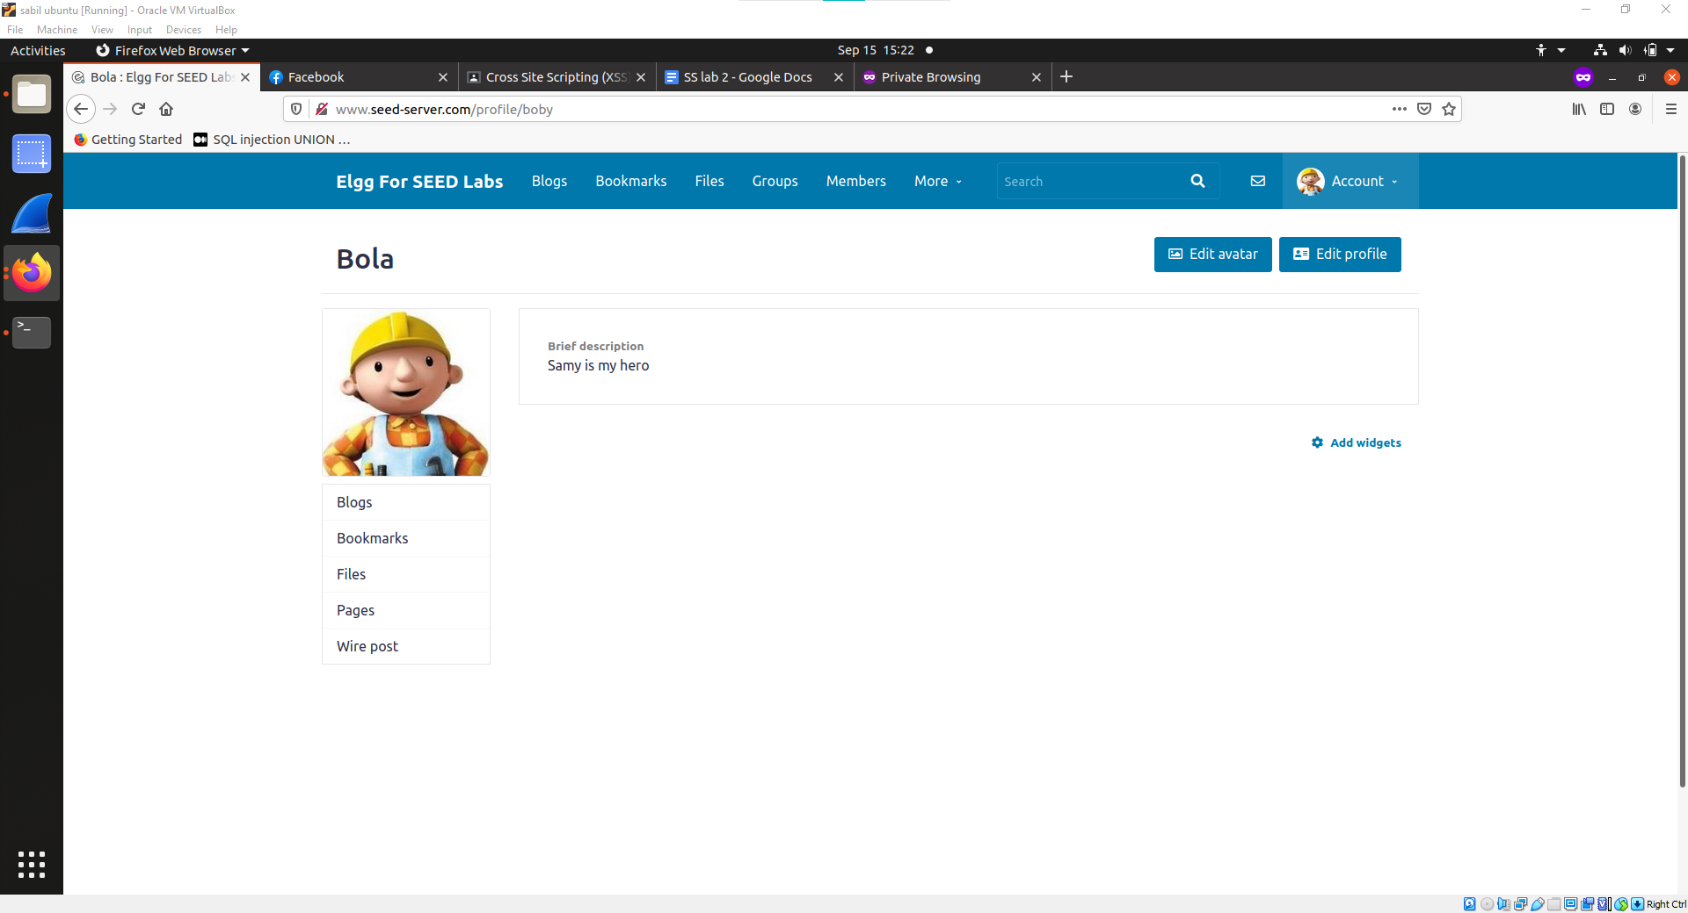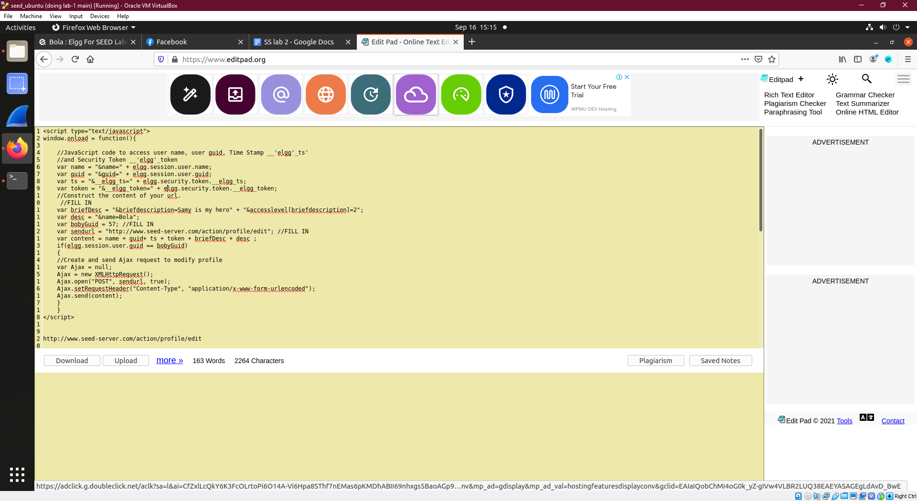

**TASK-8:**

In this task first we have to insert the script containing the code that will give out the person who is visiting the attacker’s side. In this case cookie information of the victims.

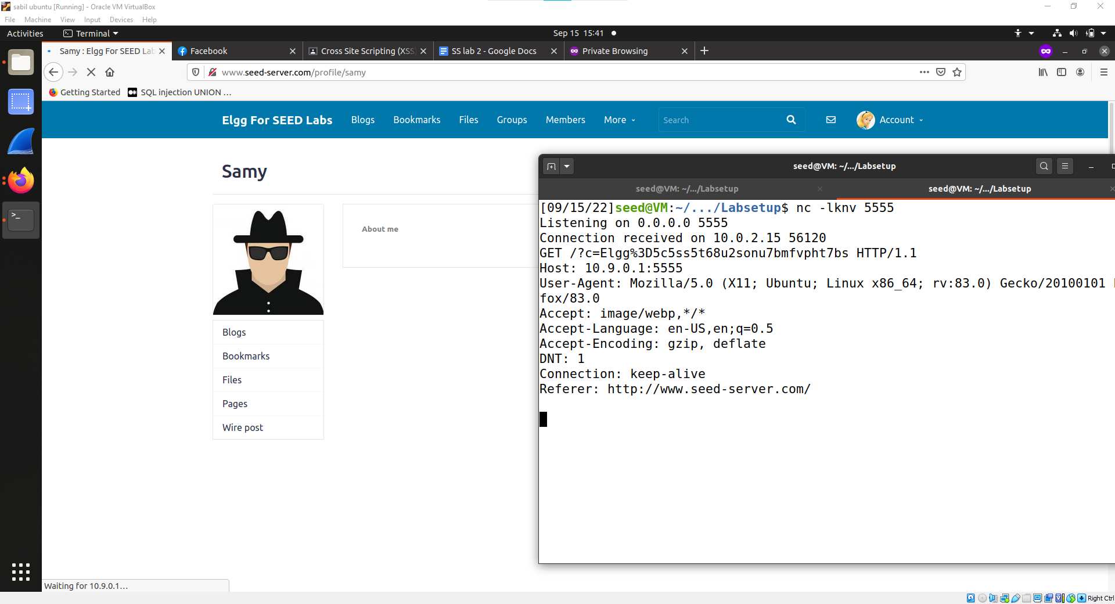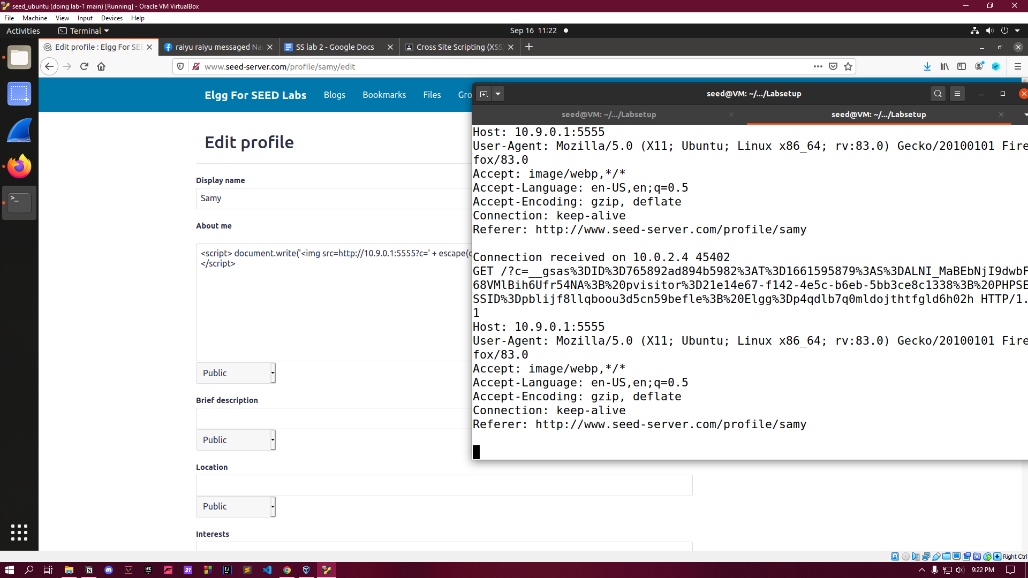

**TASK-9:**

In this task we can just use the previous script code and modify it in such a way that it will give the attacker name and guid of the victims who are visiting the attacker's profile.



